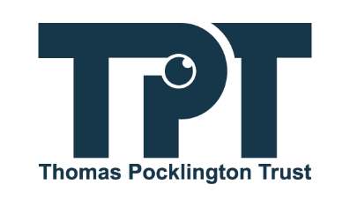
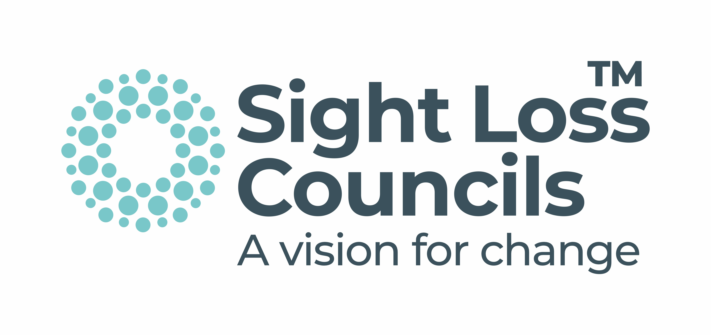

Listening Month 2024 Report:

You Said, We Did

21 October 2024
LISTENING MONTH 2024 – You Said, We Did Report

Table of Contents
1 – What Mattered to You? …………………………………….. Page 3
2 – A Sense of Priority ………………………………………….. Page 3
2.1 – Accessibility of the Built Environment ………………… Page 4
2.2 – Accessibility and Availability of Public Transport …… Page 8
2.3 – Awareness of Visual Impairment ……………………… Page 20
2.4 – Getting and Keeping Employment and Benefits ……. Page 25
2.5 – Personal Confidence and Social Isolation …………… Page 29
2.6 – Accessibility of Retail and Other Services ……………. Page 34
2.7 – Technology ……………………………………………….. Page 38
2.8 – Health and Care …………………………………………... Page 41
2.9 – Access to Education and Learning ……………………. Page 45
3 – Planned Projects for 2024 and Beyond ………………… Page 51
3.1 - Accessibility of the Built Environment ……………….. Page 51
3.2 - Accessibility and availability of Public Transport ….. Page 52
3.3 – Awareness of Visual Impairment ………………………. Page 53
3.4 – Getting and Keeping Employment and Benefits ……. Page 54
3.5 – Personal Confidence and Social Isolation …………… Page 55
3.6 – Accessibility of Retail and Other Services …………… Page 55
3.7 – Technology ……………………………………………….. Page 56
3.8 – Health and Care …………………………………………... Page 56
3.9 – Access to Education and Learning ……………………. Page 58
4 – Looking Ahead ……………………………………………… Page 59

1. What Mattered to You?
During November and early December 2022, Thomas Pocklington Trust (TPT) and Sight Loss Councils (SLCs) listened to the voices of over 1,000 blind and partially sighted (BPS) people from across England. Through a national online survey, dozens of local and national engagement events, and other formal and informal channels, we asked BPS people to tell us what mattered to them.
This report will highlight the key themes that emerged from Listening Month 2022 and will inform all of those who took the time to share their views and others who are interested, in what activities, campaigns and influence work has been taking place in 2023, the first half of 2024 and what projects are planned for the remainder of 2024.

2. A Sense of Priority
Across the Listening Month engagement, it was very difficult to identify specific priorities, with most participants listing many different themes and identifying them all as important.
However, some factors did come up in every region and strongly in the national survey, and also aligned with the priority areas identified in the Vision Impairment Lives report published in September 2022. The most common themes identified were:

2.1. Accessibility of the Built Environment (75%)
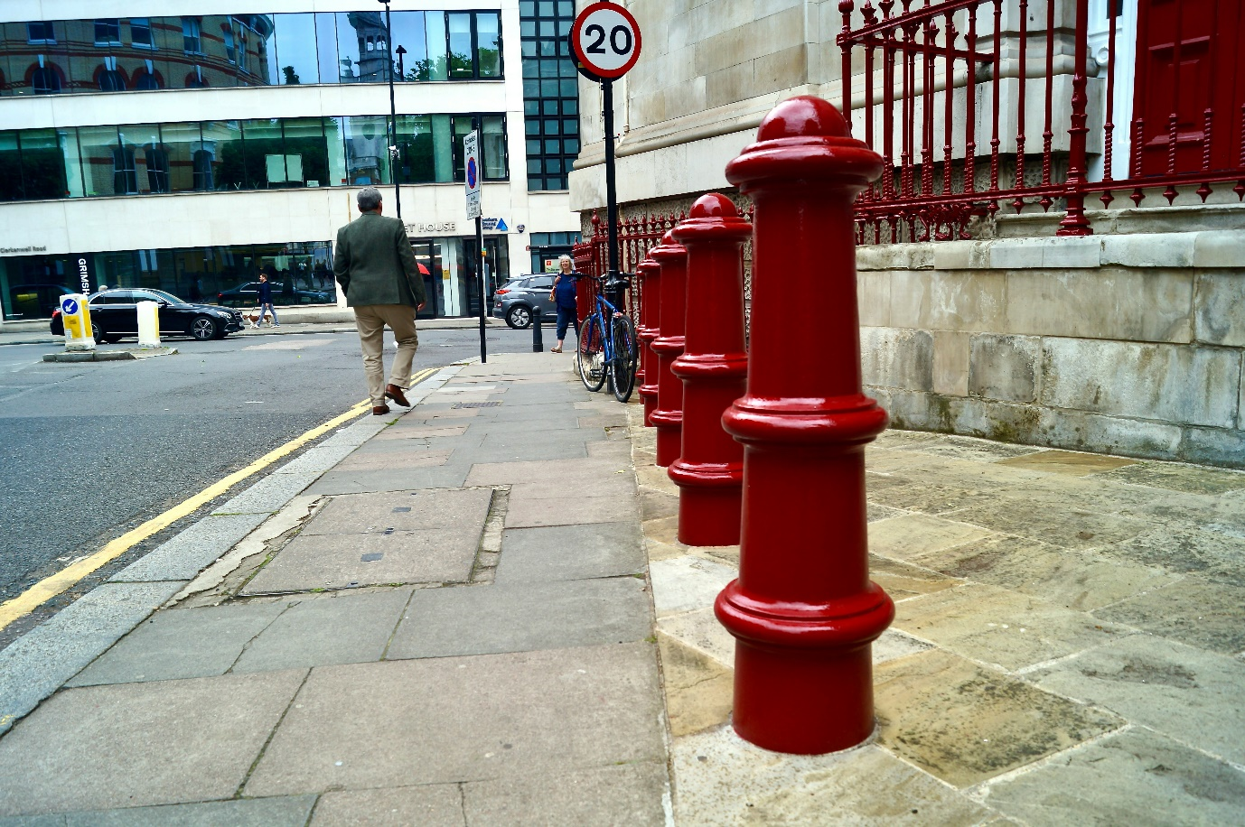

2.1.1. You Said

- Street obstacles (e.g. A Boards, overhanging vegetation, poorly placed street furniture) were a real deterrent to people and cause of accidents
- E-Scooters / bicycles being ridden inappropriately and leading to injury or nervousness about using an area
- Pavement quality was an issue for many people, with pedestrian journeys negatively impacted by pavement surface quality
- Pavement parking was a concern, with lack of local action
- Accessible crossings were generally positive but complained that often there are not enough of them or not fully functioning.

2.1.2. We Did

- Local Access Panels and Forums
SLCs are sitting on local access panels, forums and groups, with TPT representing on national bodies. This includes York Access Forum, Nottingham Disability Involvement Group, Disability Strategy Panel West Midlands, Brighton and Hove Accessible City Strategy Group and Healthy Streets Forum Wandsworth, amongst others. This feeds into consultations, strategy planning, policy making and urban development design.

- Simulated Spectacle Walks and Vision Awareness Sessions
We have been engaging with local councils and council teams to deliver visual awareness training sessions. In the Northwest, over 100 council and highways officers have taken part in Sim-Spec walks, which has led to consulting on policy change and street design improvements.
In the Northeast, London, Southwest and the East of England, the focus has been on making recreational areas more accessible to BPS people.

- Are You Worried About Obstacles on Your Pavement Activity?
This was held on 15 May 2023 at Cheltenham Racecourse, to explore some of the challenges BPS people living in Bristol or Gloucestershire face when walking down pavements and navigating their built environment, and to learn more about the planning policies around street furniture and the design of pavement and roads. Racehorse owner Andrew Gemmell, who was born blind, attended the event and shared his story into Horse Racing. The event attended by BPS people, from Bristol and Gloucestershire, formed part of the #StreetsForAll campaign and featured on SLC’s and Inclusion Gloucestershire’s social media.
“It was really helpful to get a better understanding of what the police can and can't do regarding e-scooters. I have personally found this very confusing in the past and it was good to get more information. Coming together with other visually impaired people was a positive experience. We were able to voice our concerns and, by providing feedback, change can happen.” — Emma Blackmore, Bristol SLC member.

- E-scooters
SLCs across England have been working on making e-scooters safer for the BPS community and raising awareness of the dangers they pose.
In both, East and West Midlands, the SLCs have been engaging with local authorities on e-scooter safety, featuring on BBC Politics East Midlands, to further highlight the issue around the built environment.
Additionally, London and North Yorkshire SLC have been engaging with e-scooter providers such as Tier and Lime to raise awareness and improve the safety of e-scooters themselves.
London SLC has run a joint campaign with Lime, which reached 1.5 million Lime users, encouraging them to park e-scooters and e-bikes in a safe and responsible way. Furthermore, London SLC has developed an e-bike charter, which has been shared with providers and local councils, raising rider and public awareness of the challenges e-scooters and e-bikes create. SLC Volunteer Leanne worked with Lime to produce a parking etiquette video for e-bikes, and had 2,400 views, at the time of writing. Iain Mitchell, Senior Engagement Manager for North England and the local SLC, have been working with Tier on creating an Acoustic Vehicle Alerting System (AVAS) to be fitted in Tier’s e-scooters. This sound will alert pedestrians to the presence of e-scooters in their vicinity. London SLC has created two online videos on safer use of e-bikes and e-scooters with Tier, and a TikTok with Lime, that has to date reached over 2,000 people.

- Pavement Parking
Cars parked on pavements are a big hazard and can cause serious danger. A video was produced to highlight the issue, which had over 4,700 views so far, and a joint media campaign urging the Government to introduce a new law. A consultation submitted in 2020 still has had no response or any action taken, the media campaign also highlighted this to increase pressure to do so. Articles written by Rowan and Dave reached 16,251 people, highlighting real life issues of pavement parking for those with vision loss and in a wheelchair. This was for our #TacklePavementParking campaign.

2.2. Accessibility and Availability of Public Transport (65%)
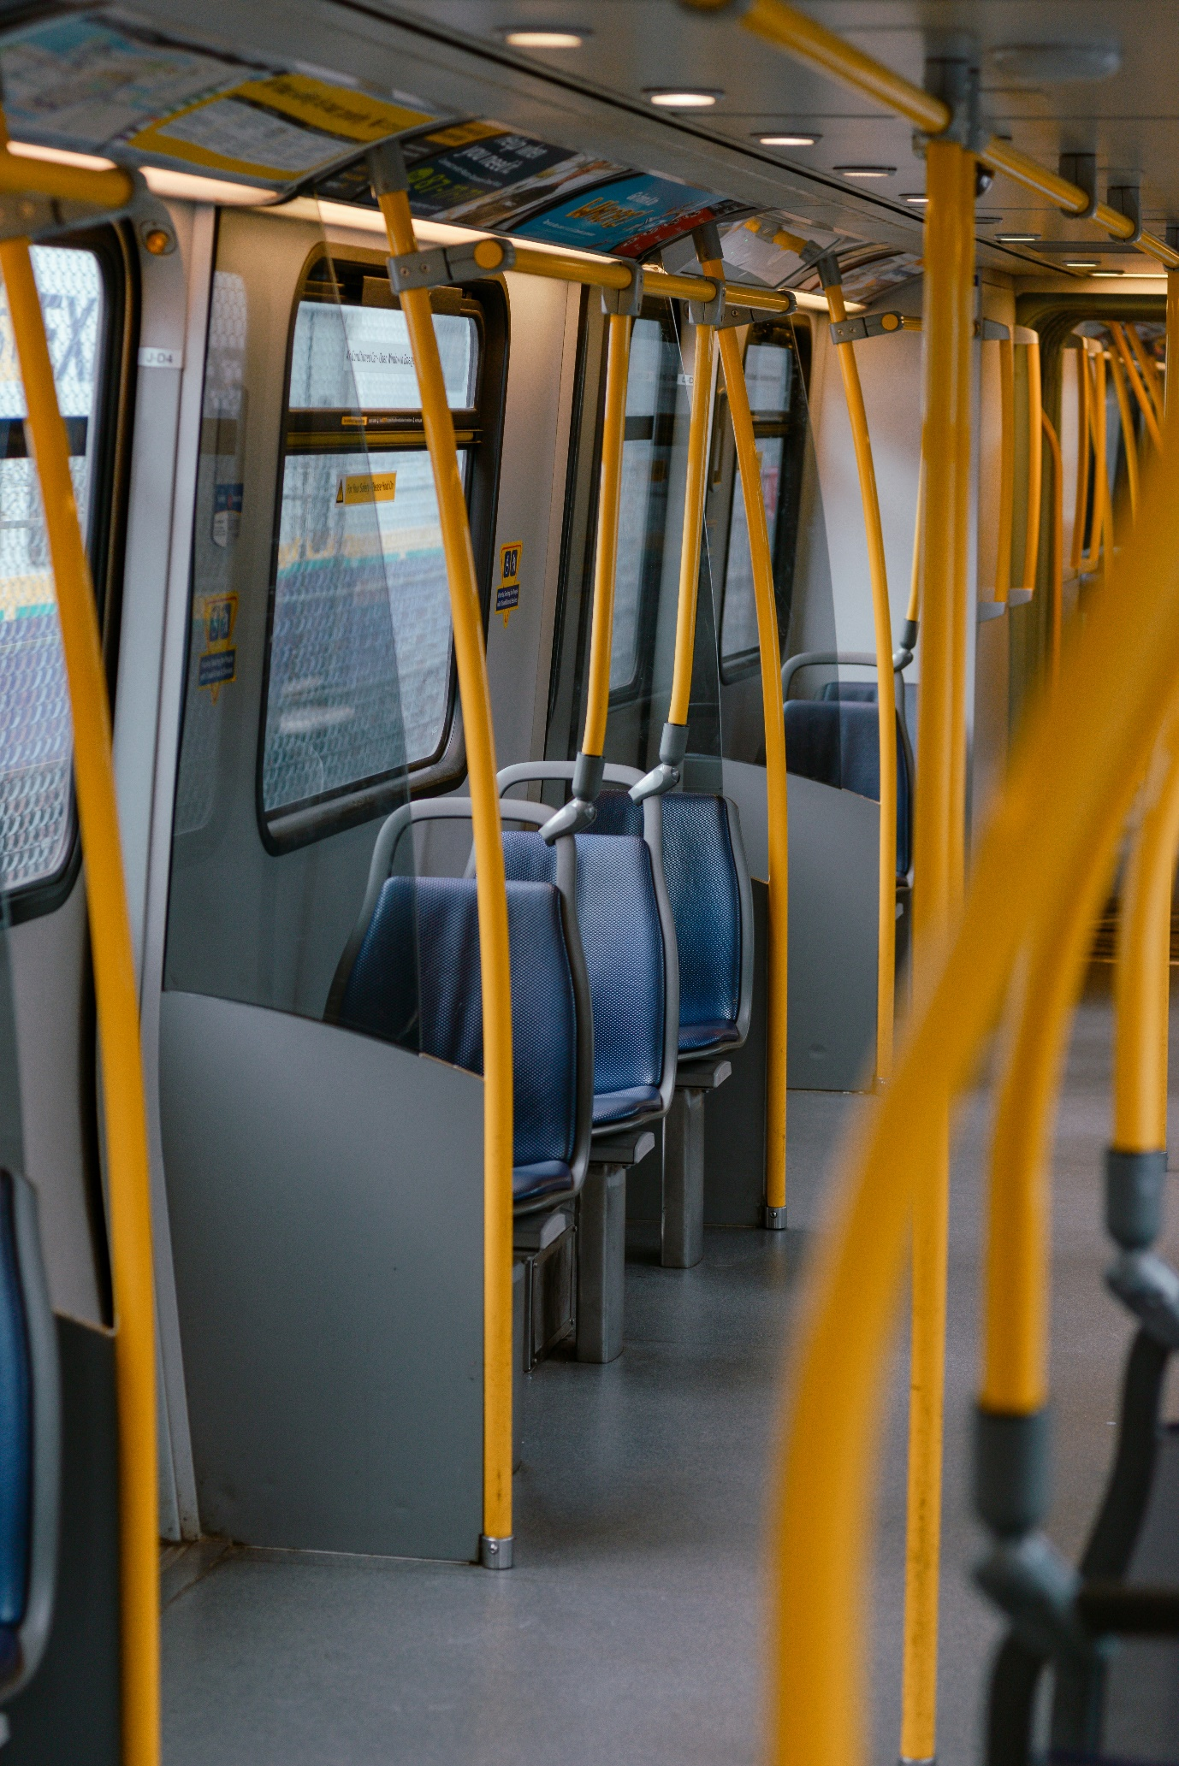

2.2.1. You Said

- Lack of audio announcements on buses or effectiveness of bus timetable information or apps
- Mixed experience of passenger assistance services on rail services, with support not always available or delivered
- Accessibility of booking services mixed, particularly when using apps and for ticketing
- Reliability of bus and rail services was a frequent complaint, adding to the uncertainty of an already stressful journey. It is very difficult to respond flexibly to delays and cancellations when you have a vision impairment.

2.2.2. We Did

- Mystery Shopping
SLCs across England conducted mystery shopping exercises on both buses and trains, whereby 84 BPS people recorded their experiences using the bus with 17 different service providers, on 86 different routes, in their local areas. In addition, SLC conducted mystery shopping on 19 different train routes with four different train service providers.
The #MakeTransportAccessible report offers some details about the findings and thus influence on targeted campaigns and projects.
- Focus Groups
In partnership with the mystery shopping exercise, SLCs and TPT undertook focus group sessions to gain a wider insight in the different experiences of BPS people who weren’t involved in the mystery shopping and who were not a part of the SLC. The sessions allowed TPT to put resources into projects, that would be the most beneficial to the BPS community.

- Accessible Travel in Brighton and Hove Forum
The East Sussex SLC and David Smith, the Engagement Manager for the South East, hosted a forum for both BPS people and key stakeholders within the transport sector. Guest speakers included Govia Thameslink Railways, Brighton and Hove Buses, and representatives from Brighton and Hove City Council. 39 people attended this event in Brighton, which focused on all aspects of public transport: trains, buses, taxis, talking bus stops and walking. It allowed BPS people to share their experiences and push for a positive change, and equally gave the transport industry the opportunity to gain feedback on future plans and seek guidance on accessibility.
“What a great event. I’ve learnt so much from attending this event, that I didn’t know. This includes finding out more about the talking bus stops and react key fob as well as being reminded about the new passenger assist app for the trains” – Steve, East Sussex attendee to the event.
“Today has been an amazing opportunity for blind and partially sighted people to share their personal experiences of using public transport. This gives all of us, as providers, inside knowledge on how we can improve it and make it more accessible for everybody. So much more can be done around access to information, not just around Talking Real Time signs, but being able to access the same information at all bus stops. We are working with bus operators to look at ways of improving things, in particular with Brighton and Hove Buses.” – Richard Johnson, Public Transport Officer for Brighton and Hove City Council.
“Everyone of us will have an accessibility issue at one point in our lives, and this is why this work is so important.” —Victoria García, Brighton & Hove Buses.
“Today has been a brilliant session and a great example of how you can come together as a collaborative group to share all the things that are available to give people the confidence to travel. It has been great to get feedback from the Sight Loss Council around areas we can look to improve overall, and Govia Thameslink Railways will continue to be committed to making the railway accessible for all.” – Carl Martin, Govia Thameslink Railways.

- SLC Conference 2023
‘Making Transport Accessible: Through the Power of Lived Experience' was the theme of the transport session, where different stakeholders from various transport sectors were invited. During this conference session, over 80 SLC members from 20 SLCs, had the chance to hear updates about accessibility and to take part in workshops to collaborate and come up with ideas to improve transport for BPS people.

Transport for London (TfL)

London SLC has developed a partnership with TfL. On 13 July 2023, Southwest London SLC member Harry shared his lived experience of using the tube network with the TfL Fleet Renewals team, which increased their understanding of sight loss, barriers to travel on the London Underground and priorities for improvement. The Fleet Renewals team also listened to the views of other disabled passengers on a panel, as part of the session. The Southwest London SLC had the opportunity to take part in TfL’s Central London Interchange Trial to inform proposed changes to bus services in Southwark and Westminster too. They were able to feedback on, and improve the accessibility of the proposed change. Six London SLC members tested new accessibility features on London bus stops and buses. This includes an audio announcement button, which announces bus arrival times, and Liquid-Crystal Display (LCD) screens, which provide clearer visual information. Again, they were able to give their feedback.

“Being severely sight impaired, I depend heavily on public transport to get around. Therefore, I have been happy to get involved with this work with TfL. This includes providing feedback on the proposed new TfL interchange and bus route changes, accessible route descriptions for BPS people, and providing vision awareness sessions to TfL’s fleet renewals team. I was also invited to share my lived experience of using the underground trains and to highlight the features I find most important. In both instances, the level of engagement and interest from TfL was fantastic and something the SLC would love to do with other transport providers.” —Harry Meade, Southwest London SLC member

“Our Customer team will now use this new text created by London SLC as an example of best practice. This will inform our current standard on the TfL website and journey planning tools for when detailing a walk to the interchange. Thank you, London SLC, for your work and effort on producing the recommended description for walking interchanges. It shows the level of description that TFL should be aiming for, with all relevant stakeholders within the business engaged to make future improvements.” — Hazel Spresser, TfL.

- ‘Meet the Bus’ and ‘Try the Train’ Events
SLCs ran several ‘Meet the Bus’ and ‘Try the Train’ events to allow for BPS people and people from within the transport industry to help promote discussion around sight loss; to provide vision impaired people with a safe space to gain confidence using buses and trains; and to help staff members to understand sight loss and why the support they offer is so vital.

‘Meet the Bus’
These events have been held in Bristol and York with First Bus, and in Gloucestershire, Merseyside and Greater Manchester with Stagecoach, and Wolverhampton with National Express. BPS people were given the chance to walk through the different bus layouts, talk to drivers and training managers about their experiences, and discuss how changes can be made to improve the accessibility of buses in the region.
Bus drivers and trainers, alongside being able to learn from the lived experiences of BPS people, were given the opportunity to try on Simulated Spectacles and then try to use the bus. A National Express representative talked about the possibility of introducing Sim-Specs into National Express’ driver training, so that recruits can use them and see what it’s like for visually impaired people boarding their buses.
“Our number one priority is that every customer feels safe and comfortable when travelling on our buses. Public transport can present challenges for those travelling with a disability, and First West of England is keen to ensure that all customers know how they can access our services.” —Chris Hanson, First West of England.
“We’re constantly looking for ways to improve our service for all of our customers and to remain as accessible and inclusive as we can. This is a great opportunity to meet our customers, gain valuable feedback and see where we can improve.” — Rachel Geliamassi, Stagecoach West.

‘Try the Train’

London and West London SLC members piloted this event at three of the major stations with Govia Thameslink Railway, with the aim to expand in other stations. The event is designed to help BPS people feel more confident in using trains, enabling them to travel independently. The SLC members lived experiences provide feedback that inform positive changes.
“I do feel that other BPS people would find a tour like this illuminating and useful. This is especially true for those who are less confident travellers. Navigating a busy station has always been a problem for me so I would always seek the assistance that is on offer.” - Harry Meade, Southwest London SLC member.

Improving Accessibility on Buses

Audible and Visual Announcements

TPT and SLCs have been doing a lot of work around Audible and Visual Announcements (AVA). The aim is to have AVA in all buses by 2026. The AVA aids will include ensuring audio is available through induction loop systems, and all new vehicles introduced after October 2024 must also include visible information, which can be seen by a wheelchair user when travelling in a rearward facing wheelchair space.

Talking Bus Stops

The SLC in Yorkshire and Humberside have been working hard to implement talking bus stops, which now have started to be installed in York.

- Stagecoach
SLCs across England have been working with Stagecoach by hosting ‘Meet the Bus’ and through round table events. Stagecoach East met with representatives from Bedfordshire SLC, Sight Concern Bedfordshire, Camsight, Health Watch Cambridgeshire & Peterborough, LOOK, and RNIB (Royal National Institute for Blind People) to consider issues such as access, safety, the implications of electric buses and giving feedback.
“It was great to work collaboratively with other national and local charities across the region to have discussions with a number of teams at Stagecoach East. Stagecoach East have been great at engaging with us and we look forward to continuing our work across the region working collaboratively to improve services for BPS people." - Samantha Leftwich, Engagement Manager for East SLC.
Bedfordshire SLC also delivered a similar Vision Awareness session, raising awareness of various eye conditions, the needs of BPS people, and delivered vision awareness training. “It was fantastic to meet and deliver this vision awareness session to such enthusiastic participants. It was a great success and integral to advancing independent travel for those living with sight loss.” - Stefan Crocker, Bedfordshire SLC member.

Govia Thameslink Railway (GTR) Aira App
SLCs worked with GTR to trial their new app Aira. The app connects BPS people to a remote advisor to improve assistance in railway stations. The advisor then uses the passenger’s smartphone camera to guide them around the station, to a member of staff. The aim of the app is to improve accessibility of rail travel to BPS people and allow them more independence. This app was trialled at Brighton, Stevenage, London Blackfriars, and East Croydon. SLC, alongside Govia, have been shortlisted for the National Rail Awards for this project. The winners will be announced in September.
“Using Aira at Brighton station highlighted to me what true independence can look like. I was very impressed with the way the agent took me to the ticket office and to a ticket machine, and the detail in which they described my environment down to details such as cones on the floor or people coming towards me with suitcases. I can’t wait to use it more on my future travels.” — Linn, East Sussex SLC volunteer.
“We want everyone to have the confidence to travel with us, no matter what their disability or need for assistance, so we’re always on the lookout for innovative ways to improve. All our staff are trained to assist our customers, whatever their needs. We hope this app can improve the support we already offer blind and partially sighted customers to put them in control of their journeys.” — Carl Martin, GTR.

- Audio Guides for Stations
During December 2022, the Bristol SLC and their Engagement Manager Alun Davies worked with Network Rail to create an audio guide for Bristol Temple Meads Station – the first of its kind. This project arose during the renovation of the station’s historic train shed roof, which made the station harder to navigate due to scaffolding towers and parts of the station being closed. The guide comprises of 12 audio files, which are housed on a dedicated page on the Network Rail website and are easily accessible from any devices, such as a smartphone or tablet. Each file guides the listener safely through a section of the station, making it far easier to navigate for BPS people.
“I’d like to congratulate Network Rail, together with the Bristol SLC, for developing this detailed audio guide. I hope it will be useful for BPS visitors, helping them to travel independently to Bristol and beyond.” —Councillor Don Alexander, Bristol City Council’s Cabinet Member for Transport.

Improving Accessibility for Network Rail Stations
In response to TPT’s letter asking for Network Rail for clarification on its plans to improve the accessibility of railway stations across their network, their Chief Executive (Andrew Haines) told TPT about Network Rail’s plan to roll out GoodMaps, an indoor navigation app across their network. This app can locate a passenger’s location in the station via their smartphone, by comparing the location and surroundings to pre-recorded station mapping. Then, via a visual and audio map, the app talks a customer through the route across a station. Manchester Piccadilly, Liverpool Lime Street, Birmingham New Street and London Euston all now have this technology available in their stations, with plans to expand this even further.
- Ticket Office Closures
TPT was a part of the many disability charities to campaign against the rail station ticket office closures. This became a big issue for, not just BPS people who relied on ticket offices, but the wider public and people who have other disabilities. TPT joined Disability Rights UK, Transport for All, The Equality Trust, the Royal National Institute for Deaf People (RNID), and the campaign was coordinated by the National Union of Rail, Maritime and Transport Workers. In addition, they provided a letter template and an address to send a letter concerning the ticket office closures, allowing BPS people to easily have their say. Following this campaign, travel watchdogs Transport Focus and London TravelWatch reported that they received more than 750,000 consultation responses and, of these, 99% were objections.

- Nottingham Express Transit (NET)
The Nottinghamshire SLC has been working closely with Nottingham Express Transit to improve the accessibility of the tram travel across the county. They met to discuss accessibility and share information, which was helpful to both parties. SLC members were able to discuss audio announcements and the high-contrast upholstery and tram fittings, as well as how inaccessible the maps are. They were also able to learn about some lesser known accessible tools and services offered by NET.
“It was great to have the opportunity to sit around the table with NET and share our experiences as BPS passengers. We certainly learned a lot from the team, and I hope that they learned a lot from us. It’s refreshing to work with a proactive organisation. It was obvious that they are keen to make tram travel as accessible and inclusive as possible. We look forward to collaborating with NET over the coming months to further enhance the passenger experience for BPS people in Nottinghamshire.” - Matt Harrison, Engagement Manager for East Midlands SLC.
“I have never travelled on the trams before but after our meeting, now feel confident to travel on my own. Staff couldn’t do enough to support us, and they went above and beyond to make tram travel accessible.” - Sian Petty, Nottinghamshire SLC member

- Ethos Farm
This is a customer experience consultancy service that works with the Department for Transport, Heathrow Airport, the Eurostar and many other organisations within the transport sector. London SLC provided an engaging visual awareness session to the Ethos Farm team. As Ethos Farm are the operators of the Heathrow Helpers team and provide over 500 colleagues at the airport, this visual awareness session allowed Ethos Farm to have a greater understanding of BPS people and how to best support them when they are travelling by plane. During the session, Ethos Farm learnt about eye care health, different kinds of eye conditions and how to support a person with sight loss, through the lived experience of staff and volunteers of the London SLC and via practical exercises. All participants felt more confident in supporting a BPS person, with 92.31% being very satisfied with the session.

- Luton Accessibility Forum
Bedfordshire SLC has been working with Luton Rising to inform the development of the Luton DART (Direct Air-Rail Transit), a new rail service that will get users from London to Luton Airport within 30 minutes. The Luton DART will also be able to take users seamlessly to their terminal. They provided feedback around the installation of tactile wayfinding routes, help points, toilets, and audio-visual announcements.
“It was a privilege to be invited to the Luton DART accessibility tour to speak about our experiences from a visually impaired perspective. Too often, new buildings and services are launched without prior consultation with accessibility groups. It was good to be able to provide feedback to the team on a range of different mobility aids. We are looking forward to continuing this partnership and engaging with them further to ensure the service is accessible to BPS people.” - Samantha Leftwich, Engagement Manager for East SLC.
Furthermore, Bedfordshire SLC was invited back to see the changes made in reaction to their feedback. This allowed them to fine-tune their advice so the Passenger Assistance team could further improve their service for BPS people.

2.3. Awareness of Visual Impairment (45%)



2.3.1. You Said

- A lack of awareness of visual impairment was a key theme mentioned by many people, with a particular emphasis on general public awareness
- People highlighted a lack of help and engagement because people didn’t know what to do
- This was perceived as being an issue that cut across a number of areas including health, retail, transport, employment, etc.

2.3.2. We Did

- Vision Awareness Sessions
In order for service providers and the general public to better understand the needs of BPS people, SLCs around the country delivered Vision Awareness Sessions, to a total of 677 attendees. The sessions were delivered to a wide range of audiences, including those within:
- Local government
- Health services: both professionals and students (for example, one session was delivered by Merseyside SLC to 50, second year radiology students)
- Police
- Commercial retail
- Sport and leisure services
- Higher education
- Arts, culture and tourism.

The interactive two-hour sessions covered different aspects of vision awareness, including:
- Highlighting daily issues faced by BPS people
- Sight loss simulation
- Sharing lived experiences
- Common eye conditions and how these affect vision
- Sector specific advice on how to best support a blind or partially sighted person
- Effective communication
- Sighted guiding practice
- Enabling technology
- Signposting to further support
- Information on how corporate organisations can, in turn, support TPT.
All sessions were tailored to suit the needs of the respective audiences via sector-specific topics and tips. Where possible, sessions were delivered in an environment relevant to the participants’ roles. This approach ensured maximum relevance and impact, with participants able to experience life as a BPS customer or service user. The Vision Awareness Sessions were delivered by TPT staff and SLC volunteers. They were offered to organisations alongside other activities, including checks on:
- Accessibility of premises
- Availability and Accessibility of online information
- One-to-one support available to BPS people
- Accessible wayfinding applications and accessible signage

The reaction to the workshops were extremely positive, with the vast majority of participants feeding back that they had learned a lot, and that they were more knowledgeable and confident in supporting BPS people.
“It was great to gain knowledge and insight from people with lived experience. The thing I enjoyed most about the session was learning about the different types of visual impairment, appreciating the challenges which some people are facing and how we can enhance someone’s experience." - SLC member
Our SLC also produced a number of useful resources to increase understanding of visual impairment, many of which have now been shared nationally, including:
- A guide on how to describe art to BPS people
- A Hints and Tips guide for retailers
- A guide for supermarkets
- Mindful shopper flyers and posters
- An online toolkit for ensuring accessible leisure facilities.

Below is a list of the different areas, across the UK, where sessions have been delivered:
- West Midlands: sessions delivered to 92 people from a variety of organisations, including leisure centres, National Trust properties, hospitals and the police
- Northwest: sessions delivered in Merseyside, Manchester and Lancashire to Retail, Arts and Culture and Health, to a total of 490 people and Sim-Spec Walks delivered in the same areas, to a total of 108 people
- The Bee Network: sessions in Merseyside, Manchester and Lancashire, to a total of 67 people
- London: approximately six Vision Impairment Awareness Sessions delivered to 60 people, including council staff and councillors, as well as retail and transport staff
- Yorkshire: sessions delivered in Wakefield Castles and Museums, Healthwatch, First Bus and Transport Advisory Group, to a total of 77 people.

- Access Gyms: Making Visual Impairment Fitness Better

The London SLC held an event at Better Gym on 11 March 2023, which aimed to increase people's confidence to access leisure facilities, and to break down some of the barriers BPS people face, as well as raising awareness of visual impairment. Around 12 BPS people attended the event, which was part of the #MakeSportAccessible campaign. Adriana Duarte and Sue Robinson, from Better Gym, spoke about processes they have implemented to make their facilities more accessible. Louise Dickson, CEO of Illuminate Freedom, talked about the inclusive dance programmes designed for BPS people that her company delivers online. A London SLC member shared his personal experience using a gym and led an open conversation with the audience on their experience of using gym facilities. Attendees then had the opportunity to participate in a touch tour of the gym and facilities and join a Vision Impairment Zumba session. After the event, they were able to take part in an optional swim session. According to data from Sport England's Active Lives Adult Survey, disabled people are nearly twice as likely to be physically inactive, with 43% reporting inactivity compared to the 23% reported by those without disabilities. For those with visual impairments, the statistics are even more telling. Half of BPS people feel that their sight loss stops them from exercising as much as they want to. Furthermore, One in three BPS people said that there are sports and fitness activities they would like to try, but have been unable to access them.
"For me it was a wakeup call, saying 'get in there and do it!' It has been very motivational for me." — Paresh, London SLC member
"It's very encouraging to see a gym wanting to be more accessible. There should be more of these sessions held London wide." - Jennifer, Southwest London SLC member
This was featured on the SLC, Better Gym and Illuminate Freedom website and social media.

2.4. Getting and Keeping Employment and Benefits (40%) 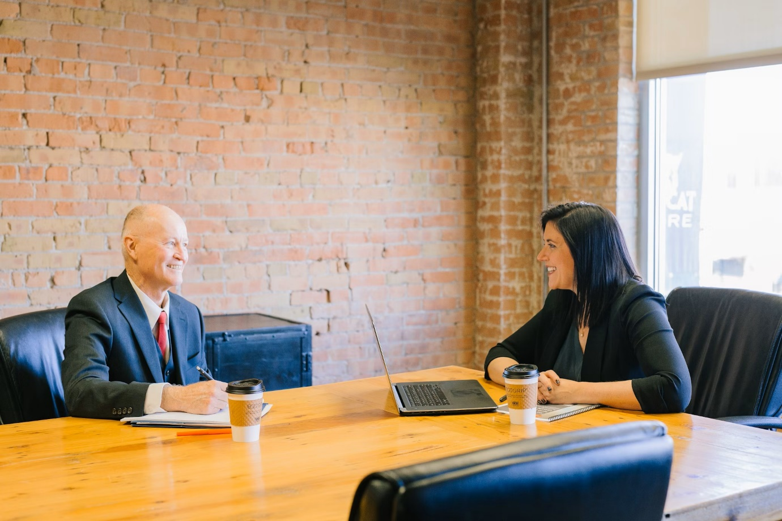

2.4.1. You Said

- Regular complaint that attitudes and understanding of employers is poor and a lack of knowledge about support available
- Concern about complexity of access to work and generally poor knowledge of the specialist equipment available to enable visually impaired people to secure jobs
- Benefits claims process was cited by many people as being complex and inaccessible.

2.4.2. We Did

All of the Employment programmes currently running are undertaken on a national basis. TPT have been running a pilot with My Sight Notts and My Sight York, whereby any enquiries we receive from clients living in these areas are referred to them, and they then receive more bespoke support for opportunities in the area that they live in. TPT have various We Work videos on their website, which highlight a range of roles undertaken by BPS individuals in all different sectors, where they talk about their journey into the career, they are passionate about. These videos have also been shared on the TPT YouTube channel.

Works For Me Programme
This is a free service dedicated to supporting BPS individuals of all working levels, providing a range of resources including job search tips, advice on completing application forms, writing cover letters and help with CVs. The programme also provides interview tips, offers mock interviews, and connects individuals with experienced career coaches. The programme offers six free sessions to help tackle clients’ career goals and also offers to have their IT skills assessed by IT experts, who advise on identifying the best assistive technology for the client’s needs and help them with the challenges people face with IT, offering solutions about equipment, along with advice on where to get training. This programme received 590 enquiries from November 2022 until March 2024, with 461 individual clients, of which 92 found work.

- Finding Your Feet Workshop
This workshop, carried out with Merton Vision in November 2023, had the Employment team on site to give advice on writing CVs, job searches, interview tips and many more aspects related to finding employment. Nine people attended the session with 2 attendees going on to full time employment - with additional support with CV writing and technology, and a further 2 stepping into voluntary roles. The group has gone on to form a peer support group where members regularly communicate and support each other on WhatsApp. We are currently looking for further organisations to host similar sessions.

- Get Set Progress (GSP)
This internship programme is tailored for BPS individuals, whether they are taking their first step onto the career ladder or returning to work after a career break. It is a nine-month paid internship in various roles within our network, providing hands-on career development opportunities. Candidates receive dedicated mentorship, specialised training, personalised support and guidance for future career planning. The programme had 40 internships completed. We had 21 intern vacancies filled in 2022/2023. Overall, there was an 85% success rate in interns securing full-time employment within six months of completing the programme.
Bhavin Koria, a former business owner and a manager, with a formal training in accounting, had lost all hope four years ago, when his eye condition started deteriorating and he was unable to run his business. With Covid striking, he had to completely shut his business to avoid any more losses. As the sole breadwinner for his family, Bhavin took up odd jobs such as a cleaner, pizza delivery person and gardener, but soon came to the realisation that with his eye condition worsening he could not carry on doing these jobs and had to utilise his accounting and business background to do something more worthwhile. Therefore, he began making several applications; in his own words, “I have made at least 100 applications, if not more, without any success”. When he contacted TPT, he was in a state of despair, but after speaking to him and working on his CV, application and interview skills, he felt much more confident for his next interview. Bhavin successfully completed the interview and is now employed as a Retail Sales Assistant with a money exchange company called Travelex.

- Corporate Talks
Moorfields Eye Hospital
We met with 40 staff members from Moorfields Eye Hospital which included Eye Care Liaison Officers (ECLOs) and Ophthalmologists to present on "Working as a blind or partially sighted person". We shared our extensive knowledge about Access to Work, the Works For Me employment programme, the Get Set Progress internship programme, sighted guide training, what support is available when losing your sight and insights of daily challenges people face. We also delivered another Corporate Talk in March 2024.
Ingeus
Some of Employment team met with Ingeus in May 2023 to discuss a new project for the Works For Me clients. Ingeus deliver an employment service on behalf of local government and local London Authorities, where they can assist Works for Me clients living in Lambeth, Lewisham, Wandsworth, Southwark, Islington, Hackney, Chelsea and Kensington, Westminster, Camden, Farringdon, Haringey and Tower Hamlets. They partner with employers to provide clients with access to local vacancies, ensuring they have the skills and knowledge to be work-ready for a wide-range of sectors and occupations. The support they provide includes a dedicated employment Key Worker/Advisor to help find the right job, as well as physical & mental health support from their in-house qualified professionals.

2.5. Personal Confidence and Social Isolation (35%)
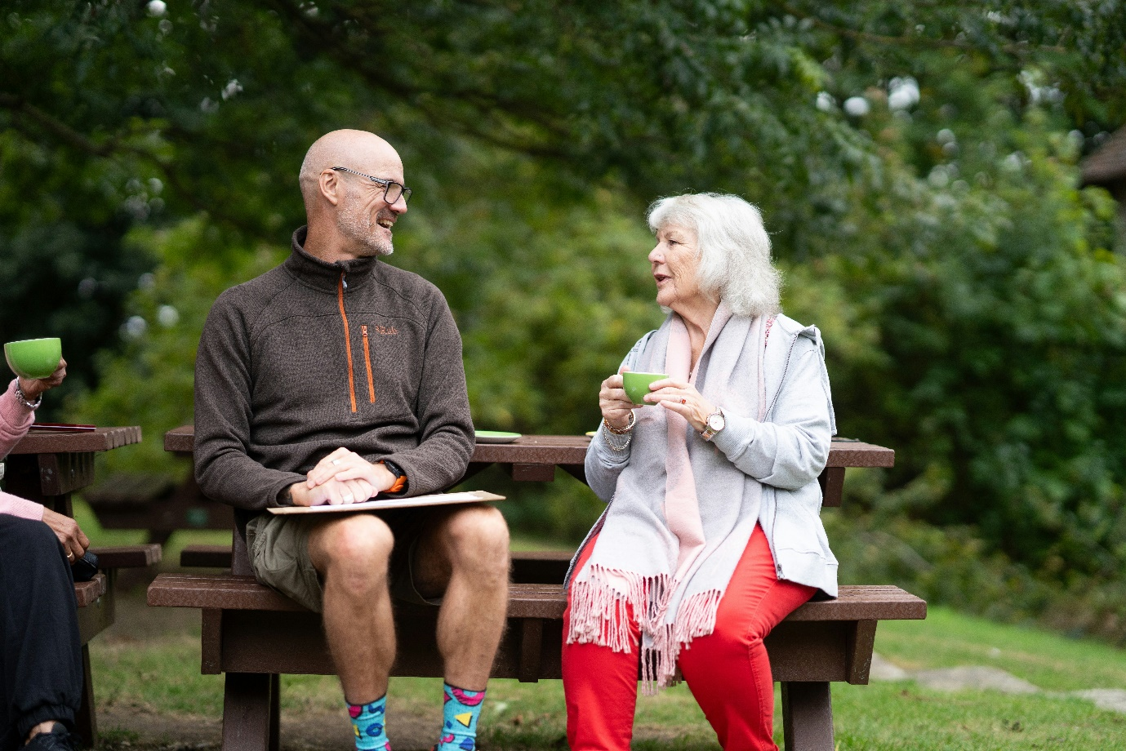

2.5.1. You Said

- Confidence to go out and about when newly diagnosed was mentioned as a barrier – with delays to getting support not helping
- Feeling of isolation from services and friendship networks. Many reported finding themselves housebound, at least initially, and consequently losing natural networks
- Mixed experience of accessing leisure and sports facilities with some very complimentary and others reporting “none exist for VI”.

2.5.2. We Did

- Let’s Get Active in Greater Manchester
This multi-sport taster event saw over 60 BPS people try a variety of sports including goalball, curling and Pilates, amongst others. The aim was to raise awareness of accessible sports and leisure activities available locally, and to increase their confidence in trying new sport activities. Additionally it aimed to improve their mental health and wellbeing through meeting new people.
“This type of event is great for anyone wanting to learn a new sport to then maybe go into a competition. It can also help people who want to get involved more for the social aspect." - Ruth, Manchester SLC Member
“The event was brilliant. We met new people, tried new things and made new friends.” – Victoria, Manchester SLC Member
The #MakeSportAccessible campaign was highlighted in a Charity Today website article.

- Let’s Get Active in York
This saw 35 BPS people living in Yorkshire and Humberside attempt a variety of sports activities, from climbing to yoga. The multi-sport taster event was designed by vision impaired people for BPS people, and was delivered by Vision Impairment sports coaches and leaders. The aim was to raise awareness of accessible sports and leisure activities available locally, and help people to get more active. It also aimed to improve the physical and mental wellbeing of local BPS residents by increasing personal confidence and decreasing social isolation.
“It’s great for people to make new friends. I encourage anyone to bite the bullet and give it a go.” —Darren, York attendee
The #LetsGetActive and #MakeSportAccessible campaigns were featured in a variety of media outlets, including an article in Yorkshire Bylines online newspaper, RNIB’s See Sport Differently podcast, and posts in England & Wales Blind Golf website and social media.

- Manchester Applying Make-Up and Skincare Masterclass
This saw many BPS people attend on a one-to-one basis, to increase their confidence when shopping for and applying makeup and skincare products. Brands ranged from Morphe and Lancôme to Kiehl’s. The attendants were shown, through a non-visual way, how to apply makeup and skincare products. For some, this was for the very first time.
"It was great to see makeup and skincare brands being demonstrated to BPS people that it is possible to apply makeup and skincare products when you have limited or no vision.” - Rachael, Manchester SLC member.
"All the makeup and skincare technicians were so friendly and encouraging. I personally learnt a great deal about applying makeup." - Gill, Manchester SLC member.
“Many guests said that after seeing us, they would have the confidence to come and see us in store for further advice.” - Debbie from Kiehl’s.
The #MakeRetailAccessible campaign was advertised in Manchester Arndale social media posts.

- Merseyside ‘Bringing Museums to Life’
This saw 40 BPS people learn more about museums and how they can access them. They explored how to make arts and culture more accessible, sharing their own experiences of inaccessibility, handling objects and going on a tour after. They heard about Museum of Liverpool's Curating for Change programme, and also learnt about other collaborations between Merseyside SLC and National Museums Liverpool to increase accessibility. Attendees then shared their experiences and aspects of museums they found inaccessible to inform future developments. They also were handed some objects on display and went on the Ken Dodd Happiness tour, an exhibition celebrating the life and career of Liverpool’s iconic comedian Sir Ken Dodd and his connect with today's comedic stars.
The #MakeMuseumsAccessible and #MakeArtAccessible campaigns gained traction from posts on the National Liverpool Museum’s website and social media and were featured on the SLC website and their social media.
"It was fantastic to have so many BPS people attend this event. A number of people hadn't been back to a museum since losing their sight. Gaining everyone's feedback was invaluable, so we can work together to address their accessibility concerns." — Michael Allaen, Merseyside SLC Member.

- Essex ‘It Belongs in a Museum’
This event saw 36 BPS people learn about what Chelmsford Museum and VocalEyes are doing to ensure BPS people can access museums, galleries and theatres across the county. The Assistant Museums Manager discussed the impact of their work with Essex SLC, the changes they have made as a result, and engaged with attendees on what else they could do to make the museum even more accessible. A VocalEyes representative then spoke about how audio description in live theatre works, sharing details of some of their work VocalEyes have done locally to increase accessibility for BPS people.
“If Essex SLC can help to provide BPS people with better services, I feel like we're having a positive impact on the community. That makes me immensely proud of what we do.” – Lee, Essex SLC Member.
The #MakeArtAccessible campaign was featured in social media posts.

- Worcestershire Peer Support Afternoon Tea

Two informative sessions were held to promote local activity and recruit new members. Over 40 BPS guests had the opportunity to find out about upcoming projects in the region and learn about the wider work of the SLC and how they could get involved.

The campaign #AfternoonTea #Worcestershire was featured on the SLC website and social media.

"Today's session went really well and it was a good opportunity to meet new people. I found the information about SLC’s very useful and how they work to improve the lives of BPS people locally. A lot of us at these groups are older and struggle to keep up with technology and online services for things. SLC’s seem like a good idea to raise awareness and make things more accessible." — A delegate at the event.

2.6. Accessibility of Retail and Other Services (30%)


2.6.1. You Said

- General complaint about lack of staff awareness in service and retail settings.
- Design of shopping and hospitality environments often poor (e.g. lighting, crowded, no natural walk routes or ways to access help)
- Mixed experience of online offer, with some apps and websites commended and others offering a poor experience
- A frequent issue was people’s mixed experience of access with a Guide Dog.

2.6.2. We Did

In order to address respondents’ concerns around the inclusivity of their shopping experiences, SLC’s and TPT’s Corporate Engagement team worked with a large number of local and national retailers. These included Apple, John Lewis, Ethos Farm, Battersea Power Station, Boots, Westfield Centre, Manchester Arndale Centre, Liverpool One, The Trafford Centre, Mill Gate (Bury), The Marketplace (Bolton), Kiehl’s and Morphe.
Activities included:
- Delivery of three retail-focused vision impairment forums
- Delivery of 14 simulation glasses walks
- Embedding a Hints and Tips document in shopping centres, reaching over 1445 stores
- Delivery of vision awareness workshops
- Conducting two accessibility checks of major shopping centres
- Hosting Purple Tuesday events at three shopping centres
- Production of information guides
- Collaboration with technology companies to address the inaccessibility of product packaging
- Delivery of a beauty masterclass to 20 BPS participants at Manchester’s Arndale Centre
- Facilitating two mystery shopping activities.

- Vision Awareness Workshops
These aimed to give participants (93 in total, excluding Southwest and Northeast) an increased confidence in understanding the needs of BPS customers, ultimately lessening the impact of vision impairment. In addition to learning about different eye conditions and how to guide a BPS customer, participants were also talked through the impact of the built environment and the Equality Act and their duties.

- Collaboration with Technology Companies
Our work has brought together leading commercial companies, such as Proctor and Gamble, and access technology innovators NaviLens. The result of this is a continuing drive to make product packaging accessible, both from a tactile and technological perspective. BPS participants within workshops were extremely positive about the developments in this area and our plans to continue this work moving forward.

- Production of Useful Resources
Retailers have been further supported via the production resources such as:
- Hints and Tips for Retailers guide
- Mindful Shopper posters and flyers
- Top Tips for Supermarket Staff in Supporting BPS Customers guide
- Addition of retail specific content to our Vision Awareness training offer

- Handling The Goods: Shopping With Sight Loss
Over 40 BPS people from across the capital joined London SLC on 23 February 2024 to find out how shopping centres, retailers and products are becoming more accessible for BPS people with assistance and technology, like the WelcoMe app or NaviLens’ code-reading app. There were guest speakers from NaviLens, Procter and Gamble and Battersea Power Station. Attendees discussed three key challenges:
- How to navigate shopping centres
- Reading product information and packaging
- How to distinguish between different products
#MakeRetailAccessible campaign has featured on the SLC and NaviLens website and social media.
“We were thrilled to welcome so many BPS people to our event. Retail has been a focus for our SLC in London since it was raised as an important issue by BPS Londoners during Listening Month 2022.” - Lucy Williams, Senior Engagement Manager for South England SLC.

- Retail Research
A Southeast SLC Coordinator has completed a comprehensive review of supermarket websites and the Northeast Engagement Manager is about to start researching priority products for accessible packaging as part of our new Accessible Packaging aim. This will include both NaviLens and tactile markings.
A survey with 50 participants in London and 20 participants in the Southeast was carried out on accessible shopping.

2.7. Technology (30%)


2.7.1. You Said

- Mixed views on technology, with many saying it was a game changer, and others saying it was unaffordable and/or inaccessible
- Big difference across ages, with older people more likely to express frustration.

2.7.2. We Did

- Tech Workshops and Employment Courses
TPT has three courses where clients can tap into, either online or in person, to equip themselves with the tools to help get into work, reaching 15 blind and partially sighted people online and two BPS people in person each week. These are as follows:
Tech Friday
These take place Face-to-face on the last Friday of every month in the Pocklington Hub. The sessions cover topics such as:
- Benefits of using a smart phone
- Apps to read text and recognise objects
- How to listen to talking books
- Apps to help take notes
- Information on screen readers & JAWS
- Windows Magnifier and how to change the displays to make them easier to see.
Tech and Talk Sessions
These happen every second Wednesday of the month, aimed at all tech abilities to get involved in exploring technologies designed to support BPS people. They are designed to share stories of using assistive technology, whether it be JAWS, VoiceOver or something completely different.
Let’s Talk Jobs
These occur every second Monday of the month on Zoom. It is a job seeker group providing an opportunity for BPS people to meet and consider their experiences of looking for work, and to learn from each other. It also includes inspirational speakers to talk about their working lives. Let’s Talk Jobs has had mixed success with 12 individuals who have dropped in to the group.

- Artificial Intelligence (A.I.)
We ran 3 seminars on the use of AI in late September 2023. Working titles include:
- AI to support with everyday living
- AI in the workplace
- AI and other apps that help you get to work.

- Education and Technology
The Information and Technology team works to ensure the Education team is providing the support information, knowledge and expertise it needs to deliver its work. They maintain and update our nearly 200 webpages to make sure BPS students, their families and professionals have the most relevant and impactful resources available. The Education team knows how important technology is and how much of a game-changer it can be for enabling BPS students to thrive in their education. That is why, in July 2023, the team launched a new section of our website, dedicated to providing new web resources which empower BPS students to super-charge their learning with the use of technology. The first series of resources focused on how to get started with the built-in accessibility features on Windows, Mac, IOS and Android, unlocking the potential of these devices for education.
In April 2024, the team launched a second wave of five exciting new resources, all about empowering BPS students to use technology to boost their productivity, work faster, smarter and more independently. They covered topics like how to take their notetaking to the next level with audio and digital apps, access printed text just using a smartphone, unlock their top-speed with touch-typing and how to use AI to super-charge their studies. The team are currently working on some exciting new additions to our Technology in Education offer, plus creating some engaging new content for our social media channels focused on tech tips for BPS students. All of this new content is fuelled by input from our student volunteers.

2.8. Health and Care (25%)

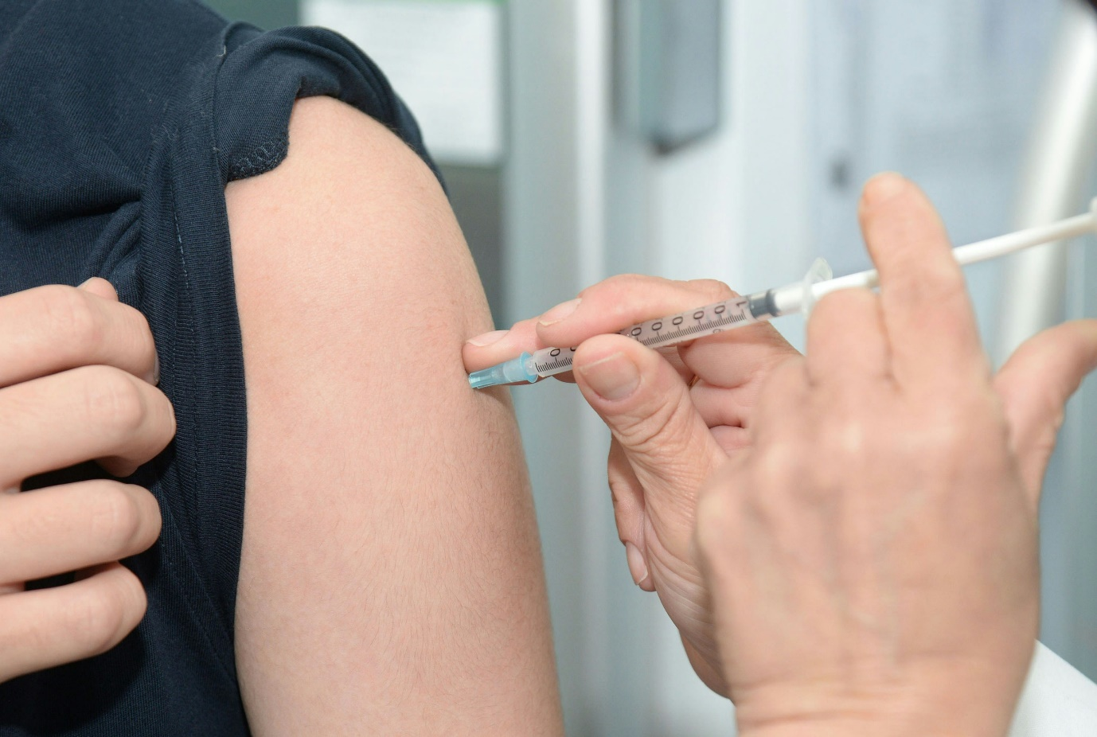

2.8.1. You Said

- Accessible health information was a key concern, with very few people expressing positive experiences
- Point of diagnosis support (e.g. ECLO, health advice, early intervention support)
- Availability of rehab services (e.g. mobility, aids and equipment, home help).

2.8.2. We Did

- ‘Make Accessible Information Standard (AIS) Work’ Film Launch
University Hospital Bristol and Weston NHS Foundation Trust (UHBW) and SLC launched two films with the goal of improving health information for BPS people right across the country. Link to further information. The health trust is on a journey to improve how the Accessible Information Standard is implemented and is working with the SLC to ensure the views of the patients are central in this. Make AIS Work shares the experiences and stories of people who are blind or partially sighted in getting health information in an accessible format. It highlights the growing work at UHBW in implementing AIS and provides practical examples other NHS Trusts and health organisations can apply that will benefit patients. This is part of the #MakeHealthAccessible campaign, which aims to celebrate the progress made in many areas while calling for increased compliance in others and, critically, to raise awareness amongst BPS people themselves of their right to request and receive information in accessible formats.
“I advise my GP and hospitals of my need for accessible information on contact with them. There are times this request hasn’t been met. I missed an urgent scan once and on another occasion was chasing an appointment I was expecting only to be told I had missed it.” - Eamon, Greater Manchester SLC Member.
“I would prefer to have information given to me in an electronic format or in braille or actually just a simple phone call, rather than print letters. […] It just makes the difference, it saves time. It just means that I can be independent and private.” - Anela, Bristol SLC Member

- Accessible Home Testing
TPT Policy & Campaigns and Partnerships teams joined forces with RNIB & NHS England to improve the accessibility of home testing kits for conditions such as bowel cancer. The new kits, called ‘FIT (Faecal Immunochemical Test) aid’ are currently being tested in the field by BPS people before being rolled out nationally. Inaccessible health tests (including cancer screening, diabetes tests and even pregnancy) mean BPS people risk detecting symptoms late and being at greater risk of serious illness than everyone else. This same situation means the NHS must pay more to treat severe illnesses that should have been avoided. Through the #MakeHealthAccessible campaign, we are asking the government to launch a pan-disability taskforce to fix this problem and deliver an action plan.

- Improving Talking Therapies for Anxiety and Depression Services
TPT launched a pilot programme in the Northeast, together with RNIB, to train therapists in the emotional impact of sight loss and how to make their services fully accessible. The pilot will lead to a change in national standards.

- Reducing Avoidable Sight Loss in Older People
By 2050, a staggering four million people could be living with sight loss, 50% of which is entirely avoidable. RNIB estimates that 80% of people living with sight loss are over 65 years old. This is why TPT is working with Age UK to encourage good eye health and reduce the numbers of older people losing their sight unnecessarily.

- ‘Eye Care & You’ Webinars
These aimed to raise awareness of specific eye conditions, and to offer sight loss advice and eye health information, giving the opportunity for attendees to gain up to date relevant information, as well as a chance for them to ask questions to the expert speaker and learn from other attendees. Topics have covered advice on independent living skills, information about services and resources and what a person with a vision impairment can seek help for. Between January 2023 and June 2024, 682 attendees joined these monthly webinars (25 so far), and we were able to answer 215 unique questions. These webinars allow attendees to ask questions to our expert speakers, which they wouldn’t normally be able to during their appointment, due to the short time they have. It also gives them confidence, by hearing from others in a similar situation, and the feeling that ‘they are not alone’.
All ‘Eye Care & You’ webinar recordings can be found on the TPT YouTube channel.

“It was a really good and informative webinar with the team and speakers. There are so many things going on for the visually impaired. Just hearing all about the different advice, tips and knowledge, gives us all hope and enthusiasm. Thank you all so much for all you do for us, and I am looking forward to the next webinar. Many thanks to everyone involved. All of the speakers have been amazing.” – Keith, Webinar attendee.

“I have been really enjoying all of the webinars and equally learning so much as a volunteer for a sight loss charity and someone who is registered blind myself. The option to watch them back is brilliant, especially if we miss something or just need to go back and listen. Thank you Bhavini and team for these wonderful webinars.” – Anjani, Webinar attendee.

  - Access to Education and Learning



2.9.1. You Said

- Due to the demographics of the participants, we received very little feedback on access to education
- We ran a separate survey and focus group aimed at young people and students, which picked up very similar themes to the main Listening Month activity
- There was strong emphasis amongst young people on the importance of accessibility of education and particularly around understanding and awareness, access to technology, and having support needs met quickly.

2.9.2. We Did

The TPT Education Team exists for BPS students, their parents and carers and the professionals that support them. We support students in secondary, further, and higher education. We believe BPS students should have the opportunity to thrive in their education. We work to improve outcomes for BPS students to ensure they can overcome the barriers they face and reach their full potential. The Education Team is made up of four sub-teams (and four additional roles have been created and filled since Listening Month 2022 due to the growth and demands put on the team)

Student Support Team
Our Student Support Service offers advice and guidance to students and the parents and professionals that support them. Direct support is provided through our telephone advice line, in addition to the information and guidance via our dedicated resources pages, and online/in person events. Since its opening in academic year 2020/2021, the enquiries coming into the service have continued to increase, going from 100 in the first year to 254 in 2023/2024; a 154% increase. We continue to see this service growth into this financial year, with 77 enquiries (and counting!) this quarter, in comparison to last year’s 52. We have also increased our Facebook community group membership, from 299 members in the first quarter of 2023/2024 to 363 members in this current quarter. We have also developed our external events offer, delivering a variety of sessions, including training at the National Association of Disability Professionals (NADP) Conference and a V.I. Fair at a special needs school, Lindon Lodge. We have reached 125 participants this quarter so far and aim to grow this reach even further in the upcoming year. The enquiries and feedback we receive through our Student Support Service informs a lot of the work we do across the Education Team, so we are not solely reliant on responses from Listening Month but have a constant feedback loop into our education offer. Examples of this can be seen in our other areas of work below.

Participation Team
The Participation Team is the newest sub-team within Education, launched in Autumn 2023. It was established to ensure student voice is at the heart of everything we do and that we reach as many BPS young people as possible, to support them and their families through their time in education.

Transition Team
Our Student Support Service receives enquiries from young people when they are navigating a transition in their education, for example from secondary school to college, so since Autumn 2023 we established our transitions offer to do more to support BPS students with these transitional periods between settings and stages of education. We started with our free #SocialEyes events, which consisted of three one-hour online events for students at secondary school, college and university around the themes of socialising, communication and networking. We had 13 students attending across these events. Our second series of events, titled #FutureVision, focused on forward planning. They followed the same format of three one-hour online events for each of the three age groups, with 26 students attending in total, doubling attendance from the first series. A
Our final series, #SeeMe, began in July 2024, supporting students with their self-advocacy skills.

Instagram
We have reflected that we are not engaging with as many BPS students as we could. A gap was identified that we could be doing more on social media to reach more students under the age of 25. Since posting more content on TPT Instagram from January 2024, we have seen an increase in engagement; +6% followers, content interactions up by over 50%, and 80% more people viewing our profile (correct as of June 2024.) The aim of Instagram is to share key resources, signpost information and share events with more BPS students.

Student Voices and Young Voices
These volunteer groups are fundamental to the work the Education Team do, inputting their experiences and ideas into our work. Some examples of projects they have been involved with are:
- Research: five students took part in the University of Birmingham research on the experiences of BPS students at university, with the aim of creating some guidance for universities to better support students with a visual impairment, especially around their socio-emotional needs
- Speaking at events: two of our Young Voices Young Leaders spoke at an event hosted by Hounslow Council called Preparing for Adulthood, which aimed to support BPS students with their future ambitions
- British Youth Council Access and Assistance for All campaign: TPT have funded phase two of a British Youth Council (BYC) project around making post-16 education accessible, especially focused on assistive technology. Five of our student volunteers have joined forces with 10 other BYC young people to encourage colleges to sign up to five pledges.

- Policy and Professional Team

Post-16 Education
We often receive feedback on the need to improve provision at post-16. The Policy Team have made this a key focus area since Listening Month 2022 and have met with civil servants and published policy statements in this area. TPT has partnered with the British Youth Council on their Access and Assistance for All campaign, which aligns with the work the Policy Team are focused on. The campaign has collaborated with organisations such as NatSpec, NASEN and Ofsted. Several student volunteers had the chance to meet David Johnstone MP (Minister for Children, Families and Wellbeing) in March 2024 to discuss their experiences of post-16 education, sharing challenges they had faced as well as examples of good practice.

IBM & SPSS
Our Policy Team works tirelessly on issues that are important to students, which often come from queries we receive through our Student Support Service. One of these was our work alongside IBM about their SPSS software, which is a software package used for the analysis of statistical data, frequently used by university students for their degrees. IBM have agreed to work with us to resolve the issues. We have established a project team, including our technology experts and student volunteers, who are now working with IBM to make SPSS accessible with assistive technology.

C.F.V.I.
The Curriculum Framework for Children and Young People with Vision Impairment (CFVI) is another project, in collaboration with RNIB, that defines the 11 areas of specialist Vision Impairment learning for BPS young people. The team is working to ensure that all children and young people can benefit from the framework, ultimately enabling them to have access to the education opportunities they need to thrive. This has been positive so far, with great feedback from those using it – the aim will be to get it used by even more people more regularly by seeing the CFVI embedded in policy across the UK.

Professionals
The Education Team also wants to offer support to the Non-Vision Impairment specialist professionals that work alongside young people, to provide them with even better knowledge and support. We have launched new and updated professional pages on our website, started a professionals newsletter focused on building a professional network, and are working towards launching a new online training. Lots of work this year has also been focussed on upskilling careers professionals, as we also know this is an area where young people are often not getting the support they need. We have published articles in careers magazines, trained careers professionals and are actively promoting a new training offer around careers.

- Information and Technology Team
You can read more about what this team does under the Technology Section (2.7).

3. Planned Projects for 2024 and Beyond

The following projects are scheduled in the later part of 2024 following the same themes as section 2.

3.1. Accessibility of the Built Environment

- Built Environment Campaigns
This will continue and will focus on the two umbrella areas:
- Social Model of Disability
- We will raise awareness of the social model of disability, by encouraging a formal adoption of the model by government departments, public bodies and local councils.

- Streets For All
- We will promote the adoption of local Street Charters to promote good practice in the built environment.
- We will continue to raise awareness of and tackling street clutter including overhanging vegetation, A boards, street furniture etc..
- We will continue to raise awareness of and tackling transport infrastructure including cycle lanes, shared space, bus lanes, floating bus stops, e-scooters, etc.

- Cut It Back
- Our #CutItBack campaign will launch in August 2024 to highlight the issues which overhanging vegetation, foliage, bushes and branches cause to BPS people and others. We have created a range of videos and resources for you to share, guidance for local authority, template letters and emails to contact businesses and councils directly within your local area. We also aim to raise awareness of how to report this issue whilst, also checking that the reporting mechanism is accessible and active. You can find out more about this wider TPT campaign here.

3.2. Accessibility and Availability of Public Transport

- Brighton & Hove, Confederation of Passenger Transport (CPT)

Following the relationship with Brighton & Hove, that Essex SLC and TPT have built, SLC have been given the opportunity to work with the Confederation of Passenger Transport to support the refresh of disability materials for the UK Governments Certificate of Professional Competence (CPC) training. This is an amazing opportunity, as 95% of bus service providers and 60% of coaches are members of CPT, and all bus drivers in England must refresh their CPC every few years. TPT and SLC will be working alongside Brighton & Hove (who are funding the project) to create two short videos that will help bus drivers gain a greater understanding of sight loss, how to help BPS passengers and why it is so important. This will be completed by late summer 2024.

- Accessibility Forum
"We look forward to working with DART (Direct Air-Rail Transit) and ARUP to deliver Vision Impairment Awareness training in the coming months. This will help ensure that all staff are confident in supporting BPS people.” - Samantha Leftwich, Engagement Manager for East England SLC.

- Audio Guides for Train Stations
This project has inspired other train stations to work with SLC’s to create similar guides, and there are plans for more to be made this year.

3.3. Awareness of visual impairment

- Visual Awareness Training
We will be working with Department for Transport DFT, Confederation of Passenger Transport CPT and Brighton and Hove buses to review and update mandatory driver training in disability, including Vision Impairment Awareness. We have already agreed to create two films and co-brand them, both with Audio Description and a standard version.

- Acoustic Vehicle Alerting System (AVAS):
TPT will continue to work with the Department for Transport to ensure that AVAS is implemented into all buses by 2026.
- Planned Visual Awareness Sessions
There are a number of planned VI Awareness sessions to be delivered to a range of organisations, across many regions, including Nottingham Express Transit staff, First Art, National Holocaust Centre, and Creswell Crags in the East Midlands.

3.4. Getting and keeping employment and benefits

- Get Set Progress
There are 13 additional internship roles, estimated to be completed in 2023/2024. We are aiming at 30 plus roles for this year’s current cohorts (2024/2025) in September 2024.
- Works For Me
We are in the very early stages of commencing a volunteer mentoring scheme for ‘Works For Me’ clients. We have started with a pilot, using seven TPT staff and five TPT Trustees as mentors and matching them with clients from our Works For Me programme. The purpose of this programme is to enhance the career prospects of the mentees and provide support through experience. Volunteer mentors will meet with mentees on the phone or virtually, for 30 minutes every month, for an initial three-month period.

- Corporate Talks
We are undertaking a programme where we are meeting with corporate companies to discuss the benefits of employing BPS people as a member of staff. In October 2023, we met with Serco in their offices in Birmingham and delivered a presentation to 40 members of their staff. We are now in talks with them to participate in the Get Set Progress programme, with a view to them possibly taking on an intern in the future.

3.5. Personal Confidence and Social Isolation

There are sessions planned with SLC volunteers and interns, which will be delivered by professional experts, around the topic of confidence building and finding your voice, using individual lived experiences. Coffee mornings will continue in various areas to build on more BPS people meeting new people and making friends, building on their confidence in travelling to the venue independently.

3.6. Accessibility of Retail and Other Services
Our Young Voices group are made up of BPS students from across the country who come together to discuss topics that are important to them and campaign to improve services which they are passionate about. This year, one team has decided to focus on retail and more specifically, accessible QR codes, such as those on offer by NaviLens and ZapVision. They are passionate about raising awareness that these exist and encourage more users to try them out for themselves. They hope this will lead to conversations with businesses to encourage wider usage of them on various packaging. There are further sessions planned in the year.

3.7. Technology

We will continue to support BPS people with using Accessible Technology and share information about these through our various work mentioned in Section 2.

3.8. Health and Care

We have a variety of topics that will be delivered through the ‘Eye Care & You’ webinars, relating to eye health, specific eye conditions, sight loss, information and advice. This will be taking place on the second Monday of each month from September 2024.
- Accessible Information Standard (AIS)
The Accessible information Standard (AIS) was introduced in 2016 by NHS England with the aim of ensuring that anyone with access needs would receive health information in their preferred format. Despite this, very few people know the AIS exists, let alone its purpose, both among NHS professionals and the patients who would benefit from it. Essentially, inaccessibility to information on appointments, records, diagnostics and treatments means inequity of access to health care. We will be continuing to champion the need for AIS.

- Accessible Screening and Medical Tests
Health screening is key to detecting conditions such as cancer, kidney and heart disease early and so it improves outcomes. But some screening programmes rely on at-home testing kits, which are not accessible for BPS people. The result of this is that BPS people are not as likely to have potential life-threatening conditions detected early and are more likely to suffer worse health outcomes than those who are not V.I. From diabetes to bowel cancer, these tests accelerate health care access, making the NHS more efficient but leaving BPS people behind, and that is why our work will focus on this. Even commercial and NHS tests such as for pregnancy and urine remain inaccessible for independent use by BPS people. Current strains on the NHS also make human support with testing less likely.

- Accessible Fitness and Social Prescribing
Increasingly, social prescribing for BPS people is becoming an inequitable issue affecting both preventative health care solutions as well as denying a clear pathway to maintaining a fit and healthy lifestyle. Together with attitudinal barriers and obstacles for BPS people to access fitness programmes, the issue requires profile and systemic solutions. Since diet also plays a crucial role in fitness – essential for diabetic management – there is also a crossover into accessible labelling and packaging of food products, therefore, we will be continuing our advocacy work around this.

- Public Facing Eye Care Pathway

The Pathway launching will be an excellent resource for BPS People, those newly diagnosed or those at risk of developing sight loss. Equally, parents and carers alike will find this resource extremely useful. We will be working towards promoting the pathway as widely as possible through various means. The Pathway will outline a variety of support, services and resources that should be available to you and will empower you to see what these may be or what you could ask for. The Public Facing Pathway will be launching at an event on 18 September 2024 and will be available for you to access on the TPT website.

3.9. Access to Education and Learning
TPT's Education team will continue their series of transitions events in the new academic year 2024-25, which are free online webinars for students moving onto their next educational stage; secondary school, college or university. They cover topics including socialising, self-advocacy and future planning. All information regarding dates, times and sign-up can be found on our website: Student Transitions - Thomas Pocklington Trust

The Education Policy team will be launching their campaign for the new government including asks and priorities to ensure BPS students have a good and equal access throughout their education. This includes promoting the CFVI further to embed it across the board to support BPS people to achieve their potential. Find out more here: Curriculum Framework For Children and Young People With Vision Impairment: Policy and Campaigning - Thomas Pocklington Trust

Our Education Policy team will also have a focus around post-16 Education and improving policy in this area. This will also link to our new free online training for professionals who work with and support BPS students within education as well. Finally, we have a student-led campaign around making colleges accessible called 'Access and Assistance for All'. The campaign encourages further education institutions to sign up to five pledges to showcase they are an inclusive and accessible college, especially around assistive tech. Find out more here: Access and Assistance for All | Make Things Accessible

4. Looking Ahead

We will be launching the Listening Month 2024 survey in October 2024, to learn if what you told us in Listening Month 2022 are still your main concerns, or if you have new challenges or priorities that matter now. We want to ensure our campaigning and influencing work aligns with what you tell us. We would also like to gain feedback to check that what you told us in Listening Month 2022, the work that TPT and SLC have carried out, has made a difference in your area. Our engagement with you is important and shapes our priorities and what we will focus on.
Thank you for reading this report and we hope you found it insightful.

