
Healthwatch England Citygate, Gallowgate Newcastle upon Tyne, NE1 4PA T: 03000 683 000
enquires@healthwatch.co.uk www.healthwatch.co.uk

Thursday 2 February 2023

Dr Neil Churchill,
Director for Experience, Participation and Equalities at NHS England Dear Dr Churchill,
We are writing to you as a coalition of national charities who have been campaigning collectively over the past year to make health and social care information accessible for everyone, including through the Your Care, Your Way campaign initiated by Healthwatch England.

We represent patients and service users around the country with sensory impairments, communication challenges and disabilities who have a legal right to receive information and communication about their health and care in formats they can understand.

As you know, in early 2022 NHS England initiated a formal review of the Accessible Information Standard (AIS), a legal duty placed on all health and social care providers to give people information about their health and care in formats they can understand, and the communication support they need to access services. The standard first came into force in 2016, and sets out a consistent approach to identifying, recording, flagging, sharing and meeting the information and communication support needs of patients.

The review process has been split into two distinct phases. There was an initial evaluation undertaken by North of England Commissioning Support Unit (NECSU) which shared its findings in June 2022. Since then, NHSE colleagues have been internally revising the AIS with the aim of having a new standard agreed by April 2023.

Our coalition has worked closely with NHS England colleagues to contribute to this process. We shared the experiences of more than 7,000 people who have accessible communication needs, commissioned additional research, and helped to coordinate patient and service user groups to provide direct evidence.

Our research has shown that in many areas people are not receiving the communication support they need, and even where services have good processes in place for identifying people’s support needs, these are not consistently met.
Healthwatch England found that of 150 NHS Trusts who responded to our Freedom of Information request, only a third (35%) said that they fully met the AIS.

A survey conducted by a coalition of the disability charities represented here found that 77% of people with accessible information needs reported rarely or never receiving information in accessible formats.

Urgent need for publication of the initial evaluation

The formal review of the AIS, especially its focus on improved implementation and accountability, has the potential to significantly reduce barriers to accessing services. We were encouraged by the people-focused approach initially taken by NECSU, who undertook the initial evaluation and produced its recommendations for NHS England.

The evidence-gathering phase of this work took the time to engage extensively with people who have sensory impairments and disabilities, and consult with the organisations represented here, as well as others with important evidence to contribute.

In summer 2022, the NECSU team drafted a comprehensive set of recommendations, drawing on the evidence collected in the preceding months as well as the recommendations developed by our coalition. We were pleased to see the final version of the NECSU report and felt that the recommendations were an accurate reflection of many of the improvements that are essential to improving people’s experiences of accessible communication. A key recommendation was the need for an updated Accessible Information Standard, to be rolled out for implementation from April 2023. In order to build public momentum behind the introduction of a revised AIS, all parties agreed it would be useful to publish the NECSU findings.

We were recently informed of an NHS England decision not to publish the NECSU report as it is not an NHS England corporate document. Coalition members have suggested hosting the report externally on one of our websites to get findings into the public domain, but we have not been given permission to do so.

The delay to publishing the NECSU evaluation is now causing significant operational challenges. It means neither NHSE, nor our coalition partners, can communicate effectively with the system or the public about any plans for implementing a revised version of the AIS.

A timeline for implementation of the revised standard
Since the NECSU report was shared in the summer, we have continued to meet with NHSE colleagues to support the programme. In September, we were very pleased to hear that behind the scenes NHSE had accepted all of NECSU’s recommendations.
While we understand NHSE colleagues are progressing with their efforts revising the AIS, we have not yet seen a new version. Given that there will need to be time for consultation and sign-off of the updated standard, it now seems highly unlikely anything will be ready to be rolled out from April 2023.
There are many implications for this delay for people’s health outcomes. For example, Integrated Care Boards do not yet have clear directions on their obligations and reporting requirements to implement the standard or address the lack of compliance of NHS Trusts we have highlighted. Many of the other NECSU recommendations are also dependent on buy-in for an updated standard and its implementation programme across the sector.
We are therefore writing to you to express our concern at the lack of public-facing updates regarding this important work. We are also concerned that insufficient resource is being invested in the process given that the AIS is a legal requirement that the NHS should have been complying with since 2016.

It has now been close to a year since NHSE announced its intention to review and revise the AIS, and despite lots of good work, we are not confident that there is an organisation-wide plan agreed for roll-out of the new standard. We are now calling on you to publish a clear timeline for this work so that colleagues across the sector know what they will need to deliver and by when.

We know that millions of people continue to experience barriers to accessing health and social care because they do not receive the communication support they need. Throughout our review we heard stories from people whose health and wellbeing had been put at direct risk from not receiving information in a way they could understand it.
Due to the lack of public communications about NHS England’s plans, the many people who contributed their stories to the review of the AIS standard have yet to see any results. Progress on the new AIS itself is of course vital to ensure these people are not denied their right to equitable access of health and social care.
Communicating progress is also important as it gives people confidence that their voices have been heard.

Our asks
In summary, we are writing to ask you for:

- NHSE to urgently reconsider its approach to publishing the NECSU evaluation report, or to rapidly give our coalition permission to publish the report to start building awareness of the coming revisions to the standard.
- NHSE to publicly set out a clear and realistic timeframe for the following:

- When a draft of the new standard will be completed
- Whether and how NHSE intends to consult on the new standard before implementation
- When the new standard would come into force
- How NHSE will continue to monitor adherence to the standard
- NHSE to set out the resourcing for this work to reassure patients about the commitment to translating the new standard into real-world improvements for people.

We are prepared to take further action if we do not receive appropriate assurance that the review will be taken forward, including through a statutory advisory note to NHS England from our coalition partners, Healthwatch England.

We continue to stand ready to support the roll-out of an updated AIS through our evidence and expertise. We are prepared to support the development of additional training for staff and to work with services to audit and improve their accessible communication processes, where we are appropriately resourced.
Yours sincerely,



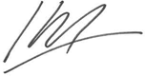
Kamran Mallick
Chief Executive, Disability Rights UK

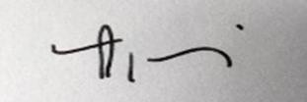

Louise Ansari
National Director, Healthwatch England
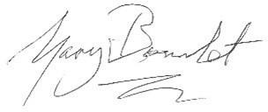

Gary Bourlet
Co-Founder, Learning Disability England

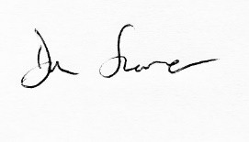

Dan Scorer
Head of Policy, Public Affairs, Information and Advice Mencap
Sarah Sweeney
Interim Chief Executive, National Voices
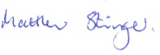

Matt Stringer
Chief Executive, RNIB (Royal National Institute of Blind People)



Lisa Hopkins
Chief Executive, SeeAbility

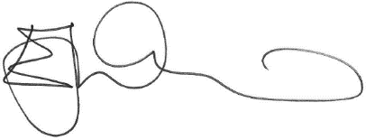

James Watson O’Neill
Chief Executive, Sign Health



Mike Bell
Head of Public Affairs and Campaigns, Thomas Pocklington Trust

